Telecomm Support Triage Agent
  - Course Name: Agentic AI

Institution Name: Medicaps University – Datagami Skill Based Course

Student Name(s) & Enrolment Number(s):
Sr no | Student Name | Enrolment Number
1 | Isha Joshi | EN22CS301438
2 | Harsh Chouhan | EN22CS301387
3 | Goutam Choudhary | EN22CS301370
4 | Goutam Sharma | EN22CS301374
5 | Harshita Chouhan | EN22CS301406

Group Name: 03D4
Project Number: AAI-39
Industry Mentor Name:
University Mentor Name:
Academic Year:2026

Problem Statement & Objectives

Problem Statement

The telecom sector is one of the most customer-centric industries where service quality and response time play a crucial role in customer satisfaction. Telecom companies receive thousands of customer queries daily related to network issues, billing discrepancies, service outages, connectivity problems, and subscription plans.
Traditionally, these queries are handled manually by customer support agents or through basic rule-based chatbots. However, these approaches suffer from several limitations:
- Manual handling leads to delays and inefficiency
- Human agents may misclassify or misinterpret queries
- Rule-based chatbots fail to understand complex natural language
- Lack of real-time prioritization of urgent issues
- Inconsistent and non-personalized responses
With the increasing volume of queries, there is a need for an intelligent, automated system that can understand user intent, classify issues, and provide meaningful responses in real time.

Project Objectives

The primary objectives of this project are:
- To develop an AI-based system capable of understanding natural language queries
- To automatically classify telecom queries into predefined categories
- To detect urgency levels based on the query context
- To extract key entities such as dates, organizations, and numeric values
- To generate context-aware responses using a Large Language Model
- To design an interactive and user-friendly interface for communication

- To integrate backend and frontend seamlessly using APIs
- To build a cost-effective system using local LLM (Ollama) instead of cloud APIs

Scope of the Project

The scope of the project includes:
Functional Scope:
- Processing telecom-related queries
- Classifying queries into categories like network, billing, technical issues
- Extracting structured information from unstructured text
- Generating intelligent responses
- Providing a real-time chat interface
Technical Scope:
- Use of FastAPI for backend services
- Integration of Ollama for running LLM locally
- Use of Streamlit for UI development
- Implementation of NER using spaCy
Limitations:
- Limited to telecom domain queries
- Does not connect to real customer databases
- Model responses depend on prompt quality
- Limited scalability without cloud deployment

Proposed Solution
The proposed system is an AI-driven Telecom Triage Agent that leverages Large Language Models to automate the processing of customer queries.
The system follows a modular pipeline:
- Input Layer: User enters query through Streamlit UI

- API Layer: FastAPI receives and processes the request
- Processing Layer:
  - Classification Module → identifies intent and urgency
  - NER Module → extracts key entities
  - Response Module → generates human-like reply using LLM
- Output Layer: Structured response is sent back to the user
This architecture ensures modularity, scalability, and ease of maintenance.

2.1 Key features
- Natural language processing using LLM
- Real-time query classification
- Urgency detection system
- Named Entity Recognition (NER)
- AI-generated dynamic responses
- Multi-turn conversation support using session memory
- Interactive UI for user engagement
- Fully local execution using Ollama (no API cost)

  - Overall Architecture / Workflow

System Architecture
The system is divided into three main components:
Frontend (Streamlit):
- Provides user interface
- Accepts user input
- Displays responses
Backend (FastAPI):
- Handles API requests
- Coordinates between modules
- Returns structured output
AI Layer (Ollama + spaCy):

- LLM handles classification and response generation
- spaCy performs entity extraction

Workflow
- User inputs query in Streamlit
- Request is sent to FastAPI endpoint /triage
- Backend processes query through modules:
  - Classifier → detects intent and urgency
  - NER → extracts entities
  - Responder → generates response
- Response is returned in JSON format
- Streamlit displays result in chat format

Data Flow Explanation
- Input: Unstructured user query
- Intermediate: Structured classification + entities
- Output: AI-generated response
This transformation from unstructured to structured data is key to intelligent decision-making.
  - Tools & Technologies Used

Programming Language
- Python: Used for backend logic and integration
Frameworks
FastAPI
- High-performance backend framework
- Used for creating REST APIs
- Supports asynchronous processing
Streamlit

- Used for building interactive UI
- Enables quick development of web apps

AI & ML Tools
Ollama
- Runs LLM locally
- Eliminates dependency on paid APIs
- Ensures data privacy
Gemma Model
- Lightweight language model
- Used for classification and response generation
spaCy
- Used for Named Entity Recognition
- Extracts structured information

Version Control
- Git and GitHub for code management

Results & Output

Observations
- The system successfully classifies queries
- Provides relevant and contextual responses
- Extracts meaningful entities
- Maintains conversation context

Performance Analysis
- Fast response time due to local execution
- No dependency on internet APIs

- Efficient for small-scale deployment

  - Outputs

Sample Outputs
Example:
Input:
“My internet is slow since last 2 days”
Output:
- Intent: Network
- Urgency: Medium
- Entities: Date
- Response: Suggested troubleshooting steps

  - Reports / dashboards / models

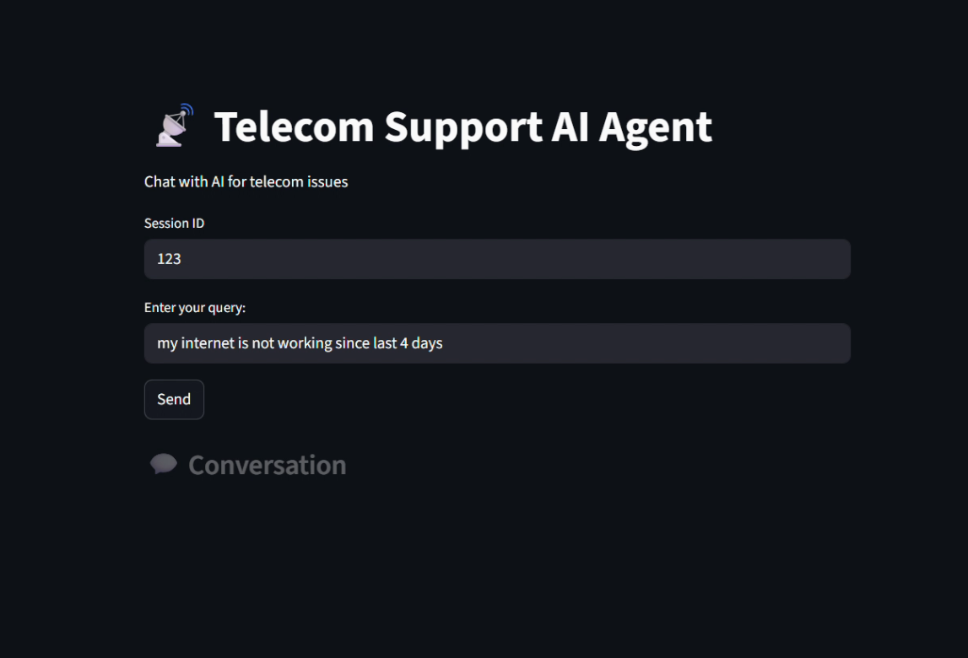

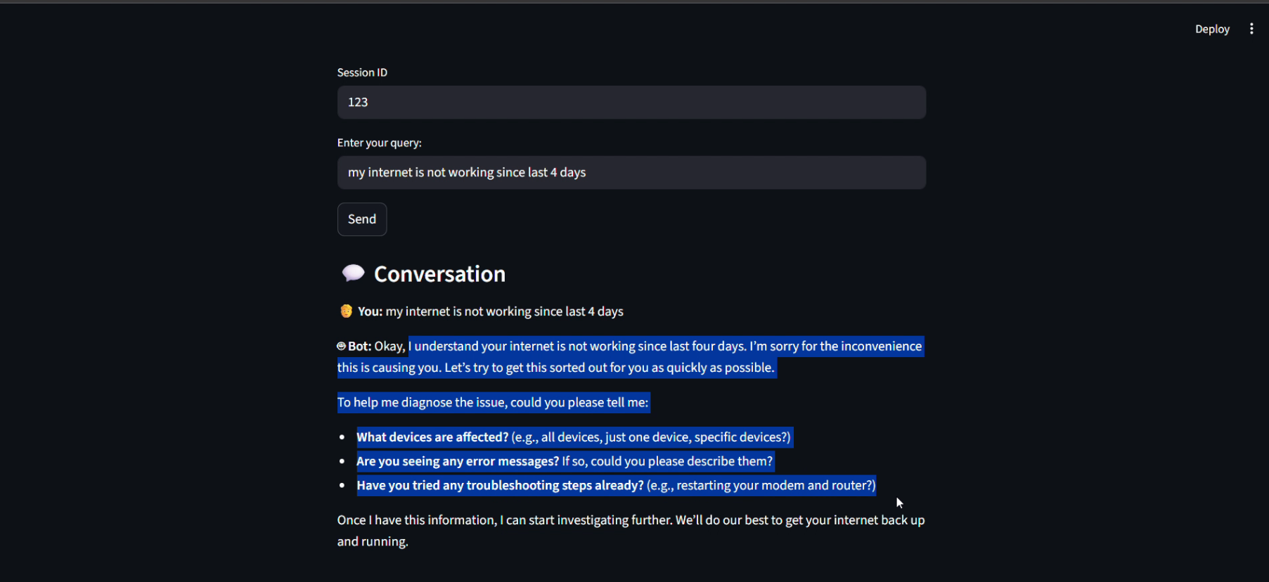

Conclusion

This project demonstrates the practical implementation of an AI-powered telecom triage system using modern technologies like FastAPI, Streamlit, and Ollama. The system successfully automates the process of understanding, classifying, and responding to customer queries.
It highlights the importance of Large Language Models in real-world applications and showcases how AI can improve efficiency, reduce costs, and enhance user experience.
Advantages of the System
- Cost-effective (no API cost)
- Scalable architecture
- Real-time processing
- Improved customer experience
- Modular design

Future Scope & Enhancements

- Integration with telecom CRM systems
- Deployment on cloud platforms
- Voice assistant integration
- Multi-language support
- Advanced analytics dashboard
- Fine-tuning of LLM for better accuracy

